1. 
2. **Agenda**: We will start with Junit.
3. 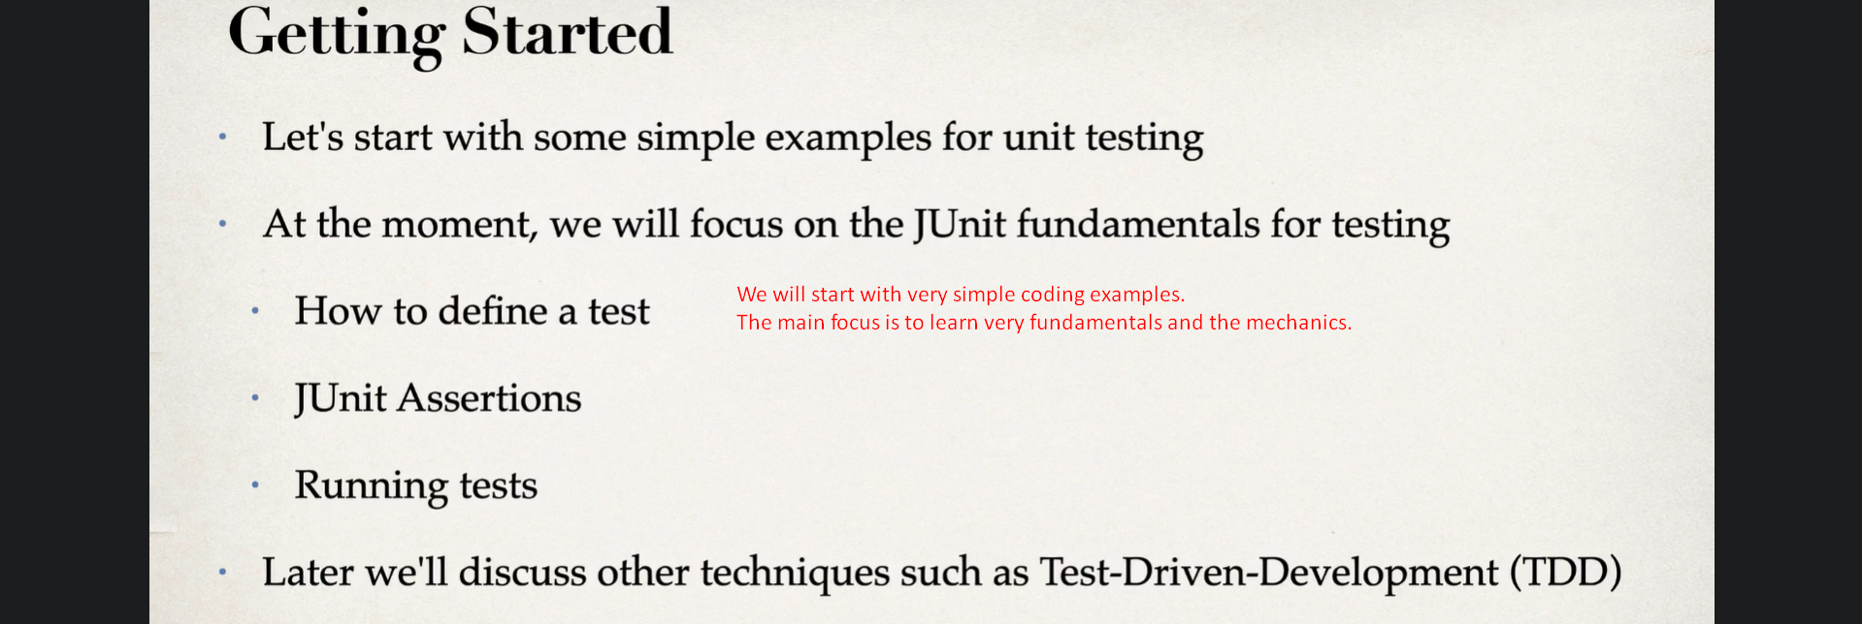
4. 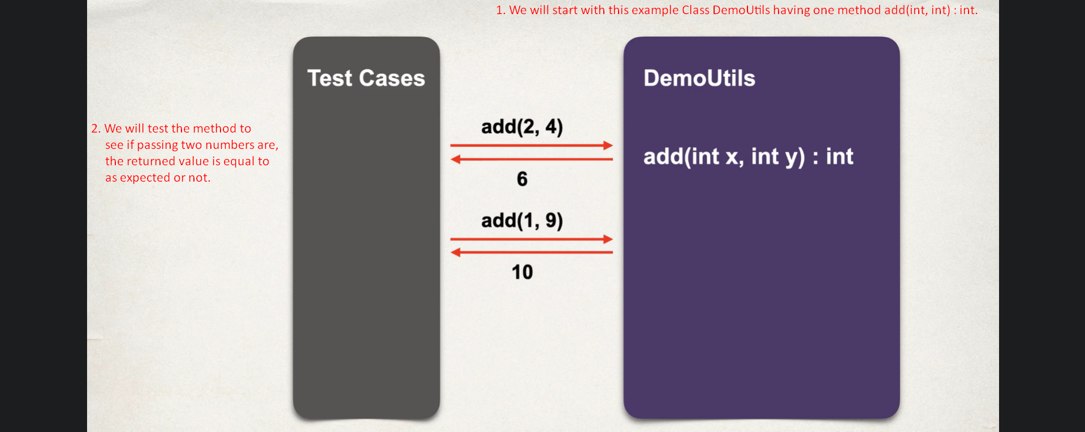
5. 
6. 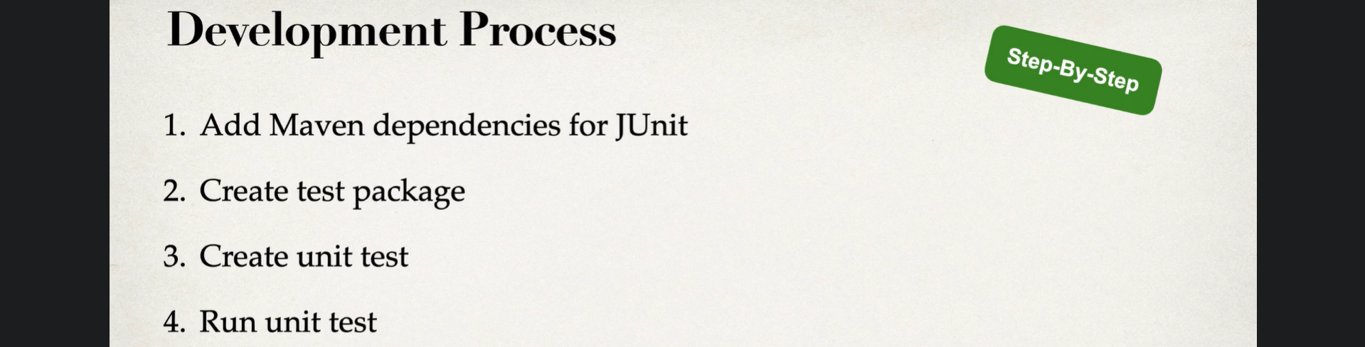
7. 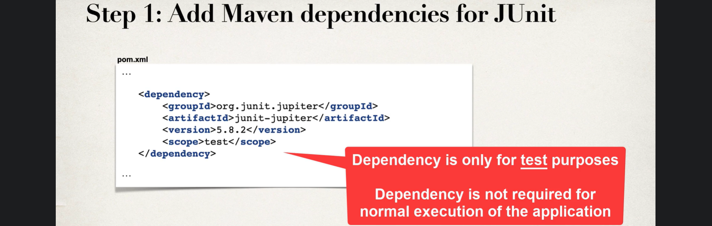
8. 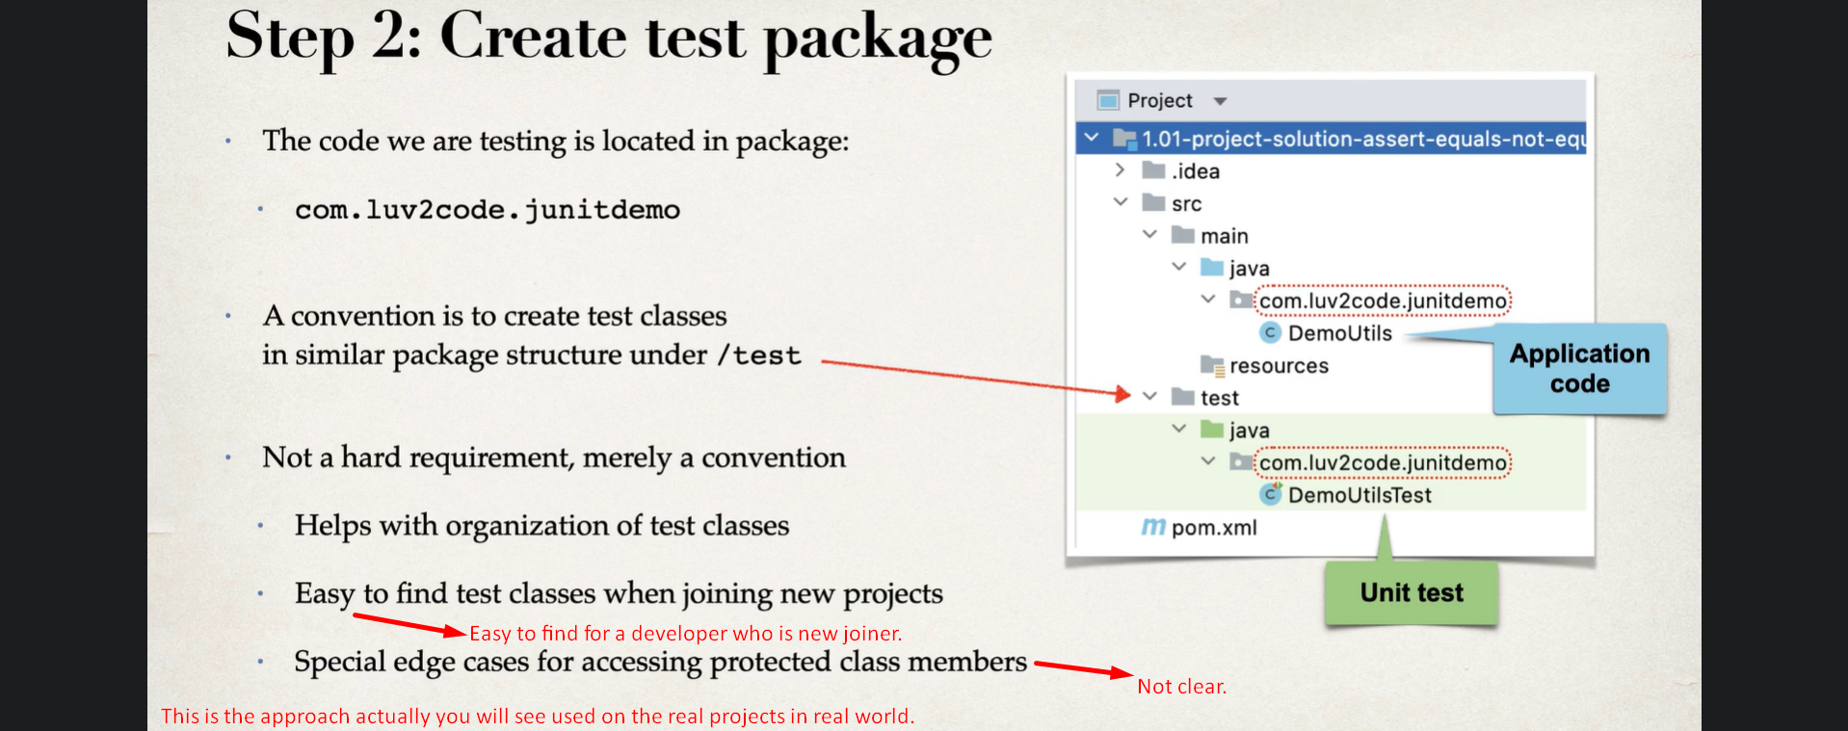
9. 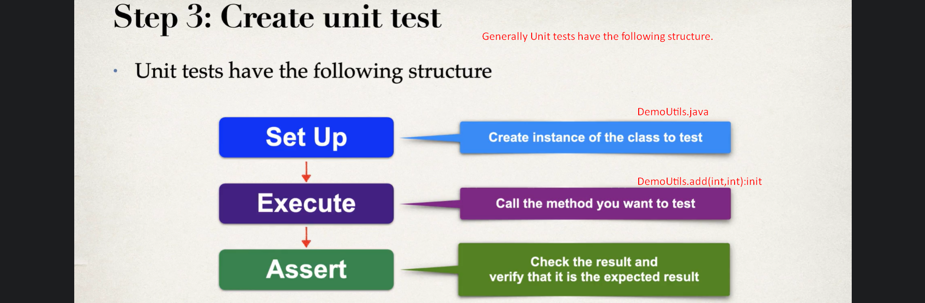
10. Let’s look at the coding example of unit tests.  
    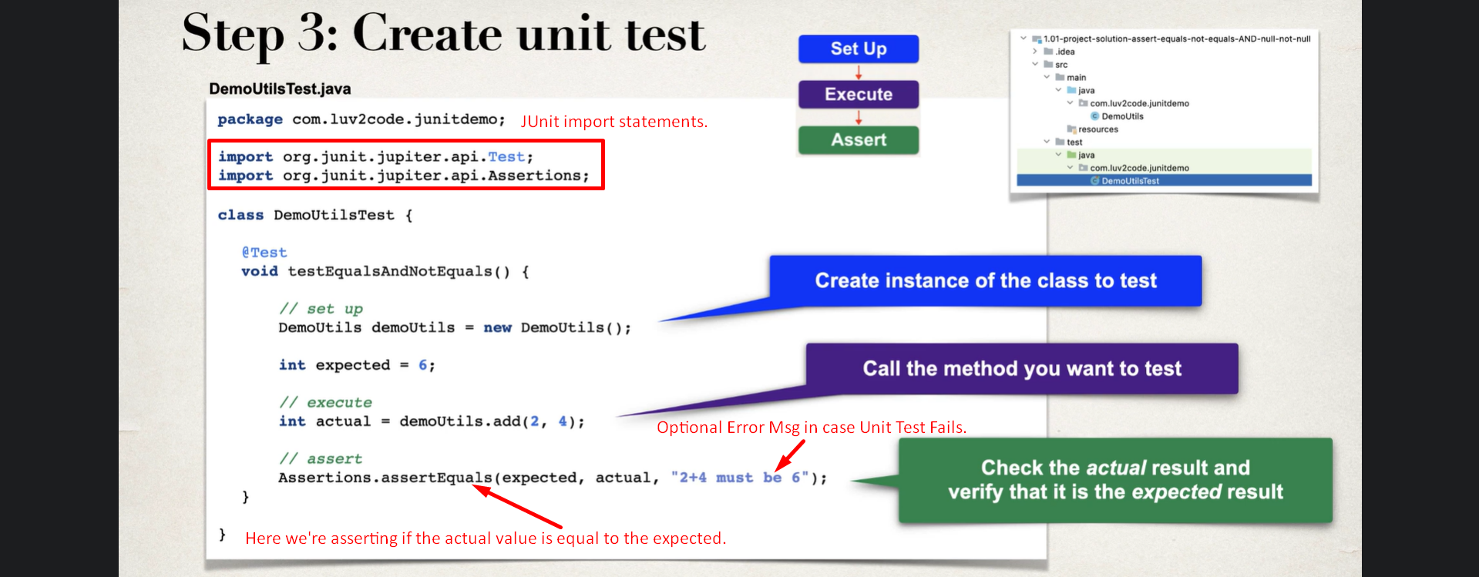
    1. @Test:
       1. To indicate that this is a test method.
       2. Test method can have any name.
11. 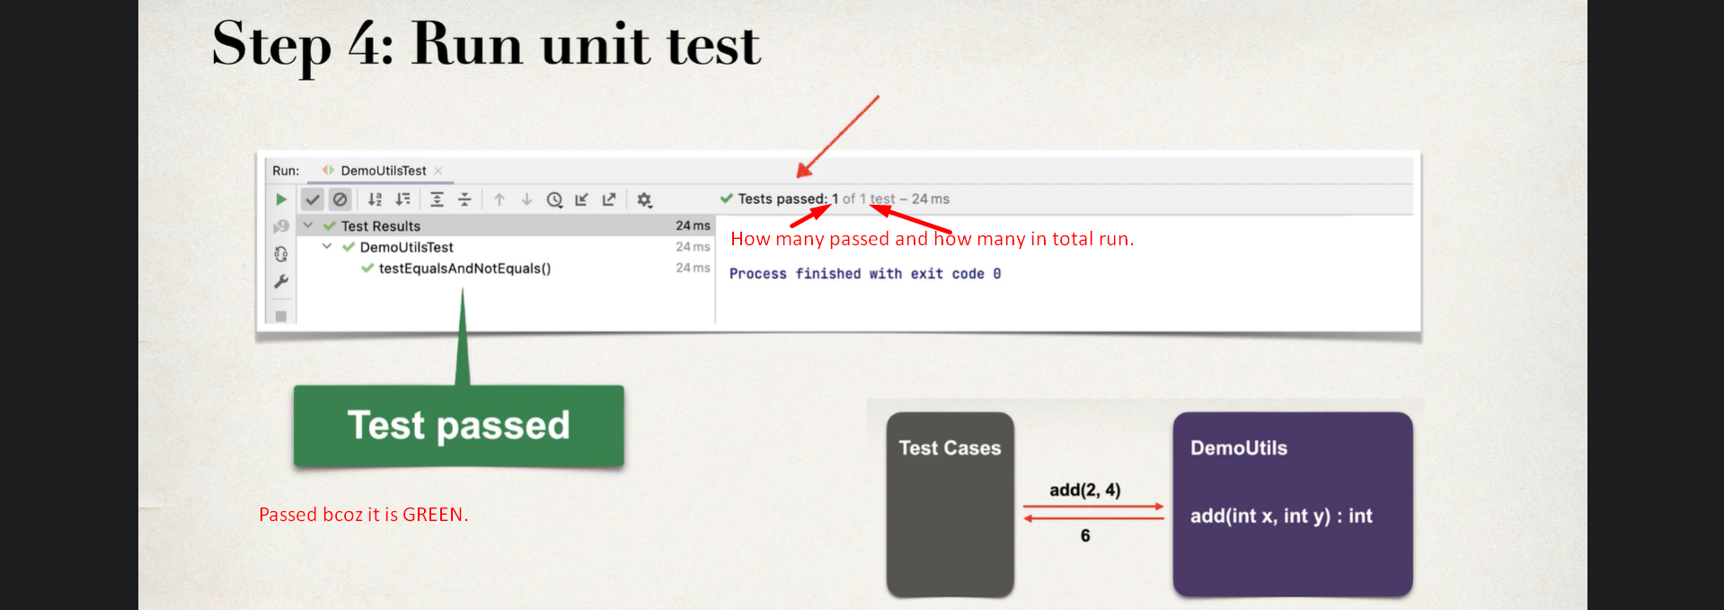
12. 